APPENDIX A CONFERENCE PRESENTATION

Our paper titled "**AI-Driven Dynamic Fuzz Testing for IoT Security: Detection and Mitigation of DDoS Attacks Using Graph Neural Networks**" has been conditionally accepted for oral presentation in the 4th International Conference on Cognitive & Intelligent Computing (ICCIC), under the Networks, Privacy & Security track. The conference will be conducted in a hybrid mode on November 29-30, 2024. Our paper ID is 223, and we have a plagiarism score of 4%.

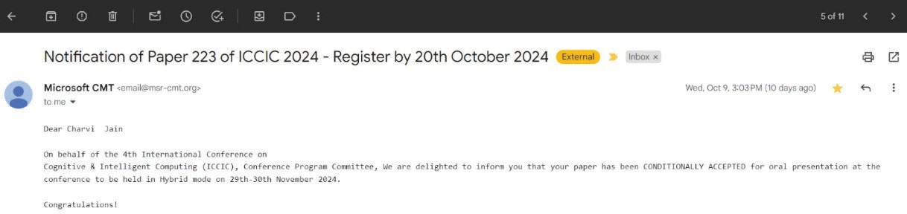



**Figure A.1: ICCIC 2024 Acceptance**